**Business Case: Target SQL**

**Context:**

Target is a globally renowned brand and a prominent retailer in the United States. Target makes itself a preferred shopping destination by offering outstanding value, inspiration, innovation and an exceptional guest experience that no other retailer can deliver.

This particular business case focuses on the operations of Target in Brazil and provides insightful information about 100,000 orders placed between 2016 and 2018. The dataset offers a comprehensive view of various dimensions including the order status, price, payment and freight performance, customer location, product attributes, and customer reviews.

By analyzing this extensive dataset, it becomes possible to gain valuable insights into Target's operations in Brazil. The information can shed light on various aspects of the business, such as order processing, pricing strategies, payment and shipping efficiency, customer demographics, product characteristics, and customer satisfaction levels.

**Problem Statement:**

Assuming you are a data analyst/ scientist at Target, you have been assigned the task of analyzing the given dataset to extract valuable insights and provide actionable recommendations.

**What does 'good' look like?**

1. **Import the dataset and do usual exploratory analysis steps like checking the structure & characteristics of the dataset:**
   1. Data type of all columns in the "customers" table.

select

  column_name, data_type

from

  `sql-project-437307.Project_DB.INFORMATION_SCHEMA.COLUMNS`

where

  table_name = 'customers';

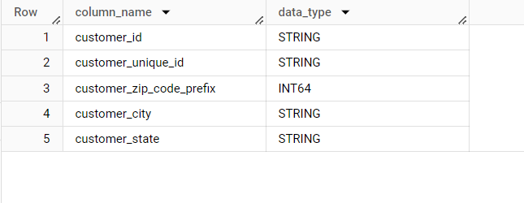

* 1. Get the time range between which the orders were placed.

select

min(order_purchase_timestamp) as time_range_min,

max(order_purchase_timestamp) as time_range_max

from `Project_DB.orders`

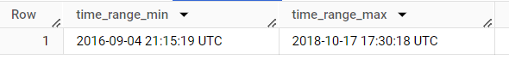

* 1. Count the Cities & States of customers who ordered during the given period.

select

customer_state, customer_city, count(*) as count_of_customers

from `Project_DB.customers`

group by customer_state, customer_city;

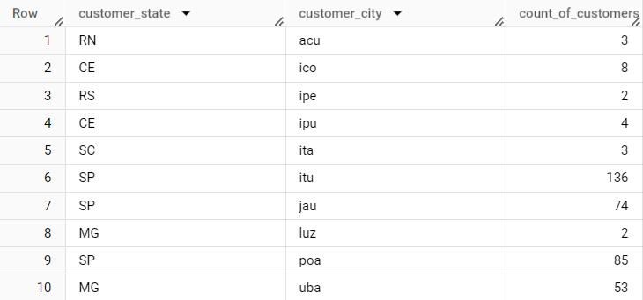

1. **In-depth Exploration:**  
   1. Is there a growing trend in the no. of orders placed over the past years?

select

  EXTRACT(YEAR FROM order_purchase_timestamp) as order_year,

  COUNT(*) AS order_count

from `Project_DB.orders`

group by order_year

order by order_year

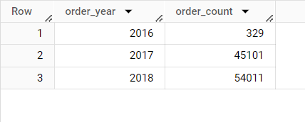

* 1. Can we see some kind of monthly seasonality in terms of the no. of orders being placed?

select

  EXTRACT(MONTH FROM order_purchase_timestamp) AS order_month,

  COUNT(*) AS order_count

from `Project_DB.orders`

group by order_month

order by order_month

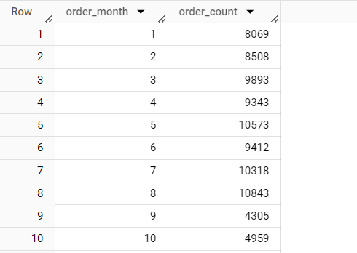

* 1. During what time of the day, do the Brazilian customers mostly place their orders? (Dawn, Morning, Afternoon or Night)
     + - 0-6 hrs : Dawn
       - 7-12 hrs : Mornings
       - 13-18 hrs : Afternoon
       - 19-23 hrs : Night

with demo1 as

(with demo as

(select

  order_id, extract(HOUR from order_purchase_timestamp) as order_hour

from `Project_DB.orders`)

select

  *, case when order_hour >=0 and order_hour <=6 then 'Dawn (0-6hrs)'

  when order_hour >=7 and order_hour <=12 then 'Mornings (7-12hrs)'

  when order_hour >=13 and order_hour <=18 then 'Afternoon (13-18)'

  when order_hour >=19 and order_hour <=23 then 'Night (19-23)'

  end as order_timings

from demo)

select

  order_timings, count (*)

from demo1

group by order_timings

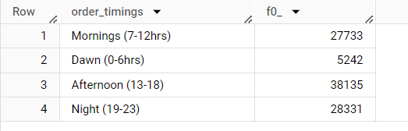

1. **Evolution of E-commerce orders in the Brazil region:**
   1. Get the month on month no. of orders placed in each state.

select

  c.customer_state,

  EXTRACT(MONTH FROM o.order_purchase_timestamp) AS order_month,

  count(*) as order_count

from `Project_DB.orders` as o

join `Project_DB.customers` as c

on o.customer_id = c.customer_id

group by c.customer_state,order_month

order by order_month, c.customer_state

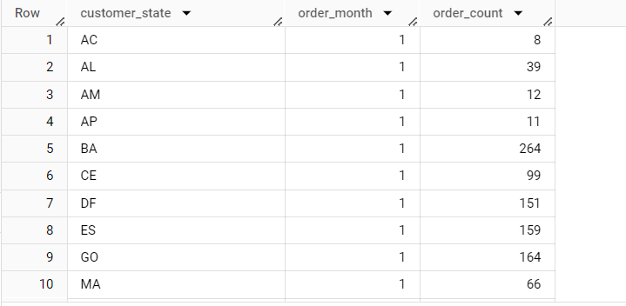

* 1. How are the customers distributed across all the states?

select

  customer_state, count(*)

from `Project_DB.customers`

group by customer_state

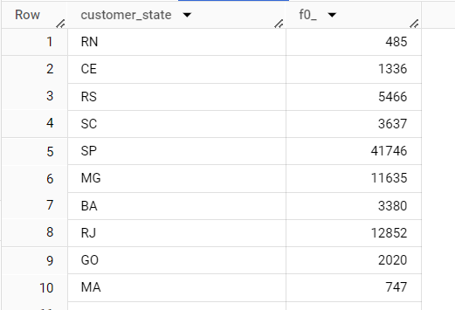

1. **Impact on Economy: Analyze the money movement by e-commerce by looking at order prices, freight and others.**

1. Get the % increase in the cost of orders from year 2017 to 2018 (include months between Jan to Aug only).  
You can use the "payment_value" column in the payments table to get the cost of orders.

with demo2 as

(with demo1 as

(with demo as

(select

  extract(YEAR from o.order_purchase_timestamp) as order_year,

  extract(MONTH from o.order_purchase_timestamp) as order_month,

  sum(p.payment_value) as cost_of_orders

from `Project_DB.orders` as o

join `Project_DB.payments` as p

on o.order_id = p.order_id

group by order_year,order_month

having order_month <= 8

order by order_year,order_month)

select

  order_year, sum(cost_of_orders) as order_cost

from demo

group by order_year

order by order_year)

select

  order_year,order_cost,

  lag(order_cost) over(order by order_year) as first_,

from demo1)

select

 order_year, order_cost,

 ((order_cost - first_) / order_cost) * 100 as cost_inc_per

from demo2

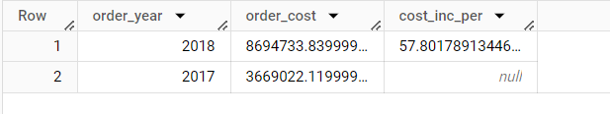

2.Calculate the Total & Average value of order price for each state.

select

  c.customer_state, sum(p.payment_value) as total_price,

  avg(p.payment_value) as average_price

from `Project_DB.customers` as c

join `Project_DB.orders` as o

on c.customer_id = o.customer_id

join `Project_DB.payments` as p

on o.order_id = p.order_id

group by c.customer_state

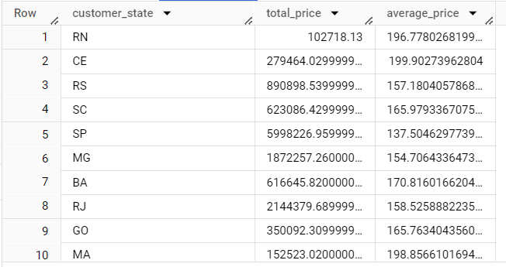

3.Calculate the Total & Average value of order freight for each state.

select

  c.customer_state, sum(ot.freight_value) as total_order_freight,

  avg(ot.freight_value) as average_order_freight

from `Project_DB.customers` as c

join `Project_DB.orders` as o

on c.customer_id = o.customer_id

join `Project_DB.order_items` as ot

on o.order_id = ot.order_id

group by c.customer_state

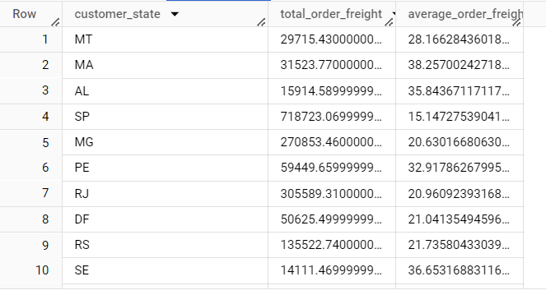

1. **Analysis based on sales, freight and delivery time.**
   1. Find the no. of days taken to deliver each order from the order’s purchase date as delivery time.  
      Also, calculate the difference (in days) between the estimated & actual delivery date of an order.  
      Do this in a single query.  
        
      You can calculate the delivery time and the difference between the estimated & actual delivery date using the given formula:
      * **time_to_deliver** = order_delivered_customer_date - order_purchase_timestamp
      * **diff_estimated_delivery** = order_delivered_customer_date - order_estimated_delivery_date

select

  order_id,

  DATE(order_purchase_timestamp) as purchase_date,

  DATE(order_delivered_customer_date) as delivered_date,

  DATE(order_estimated_delivery_date) as estimated_delivery_date,

  DATE_DIFF(DATE(order_delivered_customer_date), DATE(order_purchase_timestamp), DAY) as time_to_deliver,

DATE_DIFF(DATE(order_delivered_customer_date), DATE(order_estimated_delivery_date), DAY) as diff_estimated_delivery

from `Project_DB.Orders`;

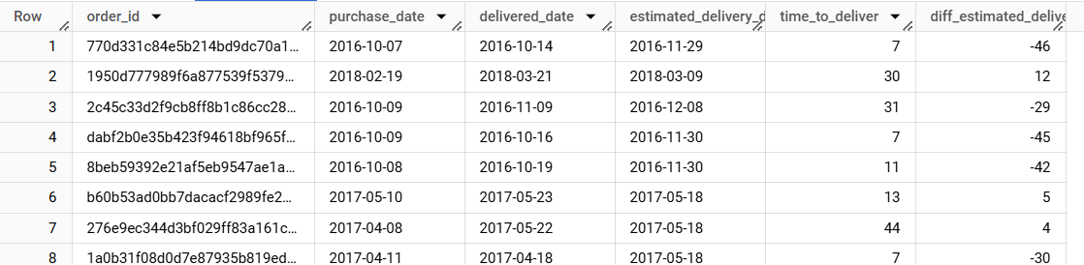

* 1. Find out the top 5 states with the highest & lowest average freight value.

select

  c.customer_state, avg(oi.freight_value) as avg_freight_value

from `Project_DB.customers` as c

join `Project_DB.orders` as o

on c.customer_id = o.customer_id

join `Project_DB.order_items` as oi

on o.order_id = oi.order_id

group by customer_state

order by avg_freight_value desc limit 5

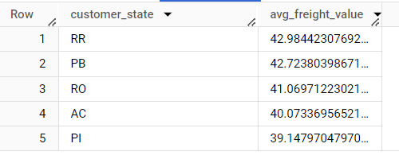

select

  c.customer_state, avg(oi.freight_value) as avg_freight_value

from `Project_DB.customers` as c

join `Project_DB.orders` as o

on c.customer_id = o.customer_id

join `Project_DB.order_items` as oi

on o.order_id = oi.order_id

group by customer_state

order by avg_freight_value limit 5

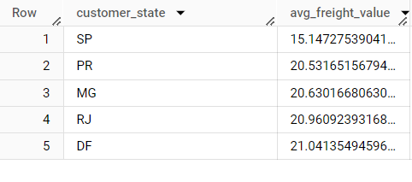

* 1. Find out the top 5 states with the highest & lowest average delivery time.

with state_delivery_times as (

 select

    c.customer_state,

    AVG(DATE_DIFF(DATE(o.order_delivered_customer_date), DATE(o.order_purchase_timestamp), DAY)) as avg_delivery_time

  from `Project_DB.customers` as c

  join `Project_DB.Orders` as o

  on c.customer_id = o.customer_id

  group by

    customer_state)

select

  customer_state, avg_delivery_time

from

  state_delivery_times

order by

  avg_delivery_time desc

limit 5;

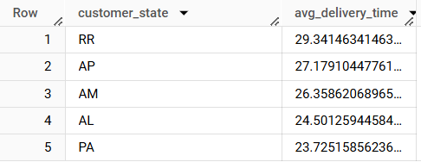

with state_delivery_times as (

 select

    c.customer_state,

    AVG(DATE_DIFF(DATE(o.order_delivered_customer_date), DATE(o.order_purchase_timestamp), DAY)) as avg_delivery_time

  from `Project_DB.customers` as c

  join `Project_DB.Orders` as o

  on c.customer_id = o.customer_id

  group by

    customer_state

)

select

  customer_state, avg_delivery_time

from

  state_delivery_times

order by

  avg_delivery_time asc

limit 5;

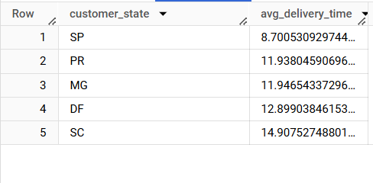

* 1. Find out the top 5 states where the order delivery is really fast as compared to the estimated date of delivery.  
     You can use the difference between the averages of actual & estimated delivery date to figure out how fast the delivery was for each state.

with state_delivery_speed as (

  select

    c.customer_state,

    AVG(DATE_DIFF(DATE(o.order_delivered_customer_date), DATE(o.order_estimated_delivery_date), DAY)) as avg_diff_actual_estimated

 from

    `Project_DB.customers` as c

  join `Project_DB.Orders` as o

  on c.customer_id = o.customer_id

group by

    customer_state)

select

  customer_state,

  avg_diff_actual_estimated

from

  state_delivery_speed

order by

  avg_diff_actual_estimated asc

limit 5;

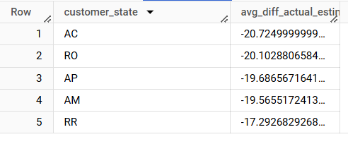

1. **Analysis based on the payments:**
   1. Find the month on month no. of orders placed using different payment types.

select

  p.payment_type,

extract(MONTH from o.order_purchase_timestamp) as month, count(*)

from `Project_DB.orders` as o

join `Project_DB.payments` as p

on o.order_id = p.order_id

group by p.payment_type, month

order by month, p.payment_type

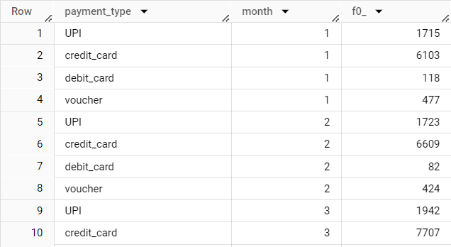

* 1. Find the no. of orders placed on the basis of the payment installments that have been paid.

select

  p.payment_installments, count(*)

from `Project_DB.orders` as o

join `Project_DB.payments` as p

on o.order_id = p.order_id

group by p.payment_installments

order by p.payment_installments

